ONLINE HARDWARE STORE
A thesis submitted
in Partial Fulfilment of the Requirements
for the Degree of
BACHELOR OF TECHNOLOGY
in
COMPUTER SCIENCE AND ENGINEERING
by
RAKESH KUMAR (130120101051)
RAHUL KUMAR SHARMA (130120101050)
NAWENDU MISHRA (130120101041)
DEEPAK KUMAR (130120101016)
Under the Supervision of
Ms Neha Gupta
Assistant Professor
Department Of Computer Science & Engineering
TULA’S INSTITUTE OF ENGINEERING AND MANAGEMENT

to the
FACULTY OF COMPUTER SCIENCE & ENGINEERING
TULA’S INSTITUTE OF ENGINEERING AND MANAGEMENT, DEHRADUN
MAY 2017

CERTIFICATION

Certified that Rakesh Kumar (130120101051), Rahul Kumar Sharma (130120101050), Nawendu Mishra (130120101041) and Deepak Kumar (130120101016) has carried out the research work presented in the project entitled “Online Hardware Store” for the award of Bachelor of Technology, from Uttarakhand Technical University, Dehradun under my supervision. The project embodies result of the original work and studies are carried out by the students themselves and the contents of the project do not form the basis for the award of any degree to the candidate or to anybody else from this or any other University/Institute.

Ms Neha Gupta
Assistant Professor
Department of Computer Science & Engineering
Tula’s Institute of Engineering and Management

Online Hardware Store

Abstract

The business-to-consumer aspect of electronic commerce (e-commerce) is the most visible business use of the World Wide Web. The primary goal of an e-commerce site is to sell goods and services online.
This project deals with developing an e-commerce website for Online Hardware Store. It provides the user with a catalogue of different hardware products available for purchase in the store. In order to facilitate online purchase a shopping cart is provided to the user. The system is implemented using a 3-tier approach, with a backend database, a middle tier of Glassfish Server and Java, and a web browser as the front end client.
In order to develop an e-commerce website, a number of technologies must be studied and understood. These include Core Java concepts, Advance Java Concepts such as EJB, JSTL, Expression Language, JPA, MVC Architecture, Glassfish server and client side scripting techniques such as HTML, CSS, JavaScript, JQuery, implementation technologies such as Java as a platform, programming language (such as Java), relational databases (such as MySQL).

This is a project with the objective to develop a basic website where a consumer is provided with a shopping cart application and also to know about the technologies used to develop such an application.

This document will discuss each of the underlying technologies to create and implement an e-commerce website. This document will also discuss all detailed report of the project.

ACKNOWLEDGEMENTS

We acknowledge our sincere thanks to those who have contributed significantly to this project. It is a pleasure to extend the deep gratitude to Director Mr. Pramod Kumar for giving me an immense opportunity to develop this project. I would also like to acknowledge our Dean of Academics, Head of Department Mr. Anuj Kumar and my class Coordinator Mr. Sachin Chaudhary for their continuous support.
We would like to thanks our internal project guide Ms Neha Gupta for all help and guidance enabled to perceive the project aspects of the project in new light. Thanks for their valuable guidance and support to continuously promote us for the project. We thank her for valuable suggestions towards our project.
We would like to thanks our family and our mates for encouraging us throughout the project duration of the project.
After all, we found a wonderful work environment in Tula’s Institute of Engineering and Management College. And this completion of project will mark a new beginning for us in coming future.

Rakesh Kumar
Rahul kr. Sharma
Nawendu Mishra
Deepak Kumar
CSE 4th Year
TABLE OF CONTENTS
Page No.
Certificate iii
Abstract iv
Acknowledgement v
List of tables vii
List of figures viii
CHAPTER 1: INTRODUCTION 1-3
1.1 Literature survey 1
1.2 Problem Identification 3
CHAPTER 2: PROJECT DESIGN 4-10
2.1 Data Model 4
2.1.1 Database Design 5
2.2 Process Model 6
2.2.1 Data Flow Diagram 7
CHAPTER 3: IMPLEMENTATION TECHNOLOGIES 11-13
3.1 EJB 11
3.2 JPA 11
3.3 JSTL 12
3.4 Glassfish Server 12
3.5 MySQL 12
CHAPTER 4: INTEGRATING WEBSITE AND DATABASE 14-16
4.1 General 14
4.2 Database Connectivity 14
CHAPTER 5: THE SHOPPING CART APPLICATION 17-30
5.1 General 17
5.2 Screenshots 17
CHAPTER 6: TRANSACTIONS IN THE APPLICATIONS 31-32
6.1 ACID Test 31
CHAPTER 7: CONCLUSION 33-34
7.1 Limitation and future work 33
7.2 Conclusion 33
7.3 References 34

LIST OF TABLES

Page No.
TABLE 1: CATEGORY TABLE 5
TABLE 2: PRODUCT TABLE 5
TABLE 3: CUSTOMER TABLE 5
TABLE 4: CUSTOMER ORDER TABLE 6
TABLE 5: ORDERED PRODUCT 6
TABLE 6: LOGIN TABLE 6
LIST OF FIGURES

Page No.
FIGURE 1: ER DIAGRAM 4
FIGURE 2: CUSTOMER-BROWSE DFD 7
FIGURE 3: CUSTOMER SHOPPING CART DFD 8
FIGURE 4: CUSTOMER SHOPPING CART DETAILED DFD 9
FIGURE 5: NEW USER REGISTRATION DFD 10
FIGURE 6: ADMINISTRATOR DFD 10
FIGURE 7: SCREENSHOT HOME PAGE 18
FIGURE 8: SCREENSHOT PRODUCT PAGE 19
FIGURE 9: SCREENSHOT PRODUCT ADDED TO CART 20
FIGURE 10: SCREENSHOT CART PAGE 21
FIGURE 11: SCREENSHOT CLEAR CART 22
FIGURE 12: SCREENSHOT CHECKOUT 23
FIGURE 13: SCREENSHOT CHECKOUT ERROR 24
FIGURE 14: SCREENSHOT CHECKOUT FILL 25
FIGURE 15: SCREENSHOT CONFIRMTION 26
FIGURE 16: SCREENSHOT LOGIN 27
FIGURE 17: SCREENSHOT ADMIN LOGIN 28
FIGURE 18: SCREENSHOT ADMIN VIEW CUSTOMER 29
FIGURE 19: SCREENSHOT ADMIN VIEW ORDER 30

CHAPTER 1
INTRODUCTION

E-commerce is fast gaining ground as an accepted and used business paradigm. More and more business houses are implementing web sites providing functionality for performing commercial transactions over the web. It is reasonable to say that the process of shopping on the web is becoming commonplace.
The objective of this project is to develop a general purpose e-commerce store where any product (such as Hardware items, computers, mobile phones, electronic items, paint items and electrical items) can be bought from the comfort of home through the Internet. However, for implementation purposes, this paper will deal with an online hardware store.
An online store is a virtual store on the Internet where customers can browse the catalogue and select products of interest. The selected items may be collected in a shopping cart. At checkout time, the items in the shopping cart will be presented as an order. At that time, more information will be needed to complete the transaction. Usually, the customer will be asked to fill a shipping address, and payment information such as credit card number. An order summary is generated on the customer screen as soon as the order is placed.

1.1 LITERATURE SURVEY

Electronic Commerce (e-commerce) applications support the interaction between different parties participating in a commerce transaction via the network, as well as the management of the data involved in the process [2].

The increasing importance of e-commerce is apparent in the study conducted by researchers at the GVU (Graphics, Visualization, and Usability) Centre at the Georgia Institute of Technology. In their summary of the findings from the eighth survey, the researchers report that “e-commerce is taking off both in terms of the number of users shopping as well as the total amount people are spending via Internet based transactions”.

Over three quarters of the 10,000 respondents report having purchased items online. The most cited reason for using the web for personal shopping was convenience (65%), followed by availability of vendor information (60%), no pressure form sales person (55%) and saving time (53%).

Although the issue of security remains the primary reason why more people do not purchase items online, the GVA survey also indicates that faith in the security of ecommerce is increasing. As more people gain confidence in current encryption technologies, more and more users can be expected to frequently purchase items online [11].

A good e-commerce site should present the following factors to the customers for better usability [11]:

- Knowing when an item was saved or not saved in the shopping cart.
- Returning to different parts of the site after adding an item to the shopping cart.
- Easy scanning and selecting items in a list.
- Effective categorical organization of products.
- Simple navigation from home page to information and order links for specific products.
- Obvious shopping links or buttons.
- Minimal and effective security notifications or messages.
- Consistent layout of product information.

Another important factor in the design of an e-commerce site is feedback. The interactive cycle between a user and a web site is not complete until the web site responds to a command entered by the user. According to Norman [5], "feedback--sending back to the user information about what action has actually been done, what result has been accomplished--is a well-known concept in the science of control and information theory. Imagine trying to talk to someone when you cannot even hear your own voice, or trying to draw a picture with a pencil that leaves no mark: there would be no feedback".

Web site feedback often consists of a change in the visual or verbal information presented to the user. Simple examples include highlighting a selection made by the user or filling a field on a form based on a user's selection from a pull down list. Another example is using the sound of a cash register to confirm that a product has been added to an electronic shopping cart.

Completed orders should be acknowledged quickly. This may be done with an acknowledgment or fulfilment page. The amount of time it takes to generate and download this page, however, is a source of irritation for many e-commerce users. Users are quick to attribute meaning to events. A blank page, or what a user perceives to be "a long time" to receive an acknowledgment, may be interpreted as "there must be something wrong with the order." If generating an acknowledgment may take longer than what may be reasonably expected by the user, then the design should include intermediate feedback to the user indicating the progress being made toward acknowledgment or fulfilment.

Finally, feedback should not distract the user. Actions and reactions made by the web site should be meaningful. Feedback should not draw the user's attention away from the important tasks of gathering information, selecting products, and placing orders.

1.2 PROBLEM IDENTIFICATION

The Online Hardware Store is an e-commerce web portal through which customers can buy items such as electrical items, hardware items, paint items, wooden items etc. Many times we see that people who are building their houses or wants to build or a contractor doesn’t have time to really go at shop and in such a condition he/she has to be dependent on others and compromise with their dream quality of the product. Our website will offer the same product within a short span of time and that too of a premium quality. This website will work as a platform for the seller of different region and the customer. We are providing a platform where a seller can register themselves and after some verification they can start selling products.
It is aimed to reduce the amount of time and cost spent by the customers in searching for the product in the market. The main goal is targeting towards smooth internal communication and functioning for the customers along with other useful information.
- Time and cost saving to reach to people.
- Time saving for persons of remote places for their product search and also provides the convenience of searching for products anywhere at any point of time.

CHAPTER 2

PROJECT DESIGN

In order to design a web site, the relational database must be designed first. Conceptual design can be divided into two parts: The data model and the process model. The data model focuses on what data should be stored in the database while the process model deals with how the data is processed. To put this in the context of the relational database, the data model is used to design the relational tables. The process model is used to design the queries that will access and perform operations on those tables.

2.1 DATA MODEL

A data model is a conceptual representation of the data structures that are required by a database. The first step in designing a database is to develop an Entity-Relationship Diagram (ERD). The ERD serves as a blue print from which a relational database maybe deduced. Figure 1 shows the ERD for the project and later we will show the transformation from ERD to the relational model.

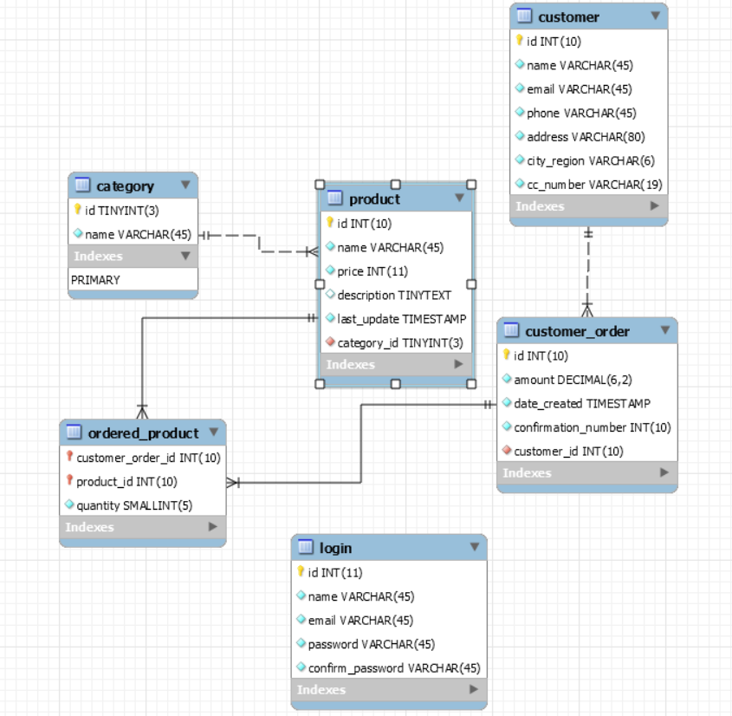
Figure 1. ER Diagram
Here entity “product” matches exactly one record in entity “category” and every record in “category” matches many records in “products”. One to many means that every record in A matches zero or more records in B and every record in B matches exactly one record in A. If there is a one to many relationship between two entities, then these entities are represented as Associative Entities. In the Relational Database model, each of the entities will be transformed into a table. The tables are shown below along with the attributes.

2.1.1 DATABASE DESIGN

In this section, the basic structure of the tables composing the database for the project are shown along with information about primary and foreign keys.

Category

S.No. | NAME | TYPE | DESCRIPTION
1 | Id | TINYINT(3) | Primary key for category identification
2 | Name | VARCHAR(45)

Product

S.No. | NAME | TYPE | DESCRIPTION
1 | Id | INT(10) | Primary key for product
2 | Name | VARCHAR(45)
3 | Price | INT(11)
4 | Description | TINYTEXT
5 | Last Update | TIMESTAMP | Auto generated
6 | Category Id | TINYINT(3) | Foreign key

Customer

S.No. | NAME | TYPE | DESCRIPTION
1 | Id | INT(10) | Primary key For customer
2 | Name | VARCHAR(45)
3 | Email | VARCHAR(45)
4 | Phone | VARCHAR(45)
5 | Address | VARCHAR(80)
6 | City Region | VARCHAR(6)
7 | Credit Card Number | VARCHAR(19)

Customer Order

S.No. | NAME | TYPE | DESCRIPTION
1 | Id | INT(10) | Primary key for Customer Order
2 | Amount | BIG DECIMAL(6,2)
3 | Date Created | TIMESTAMP | Auto Generated
4 | Confirmation Number | INT(10)
5 | Customer Id | INT(10) | Foreign Key to customer

Ordered Product

S.No. | NAME | TYPE | DESCRIPTION
1 | Customer Order Id | INT(10) | Foreign Key to Customer Order
2 | Product Id | INT(10) | Foreign Key to Product
3 | Quantity | SMALLINT

Login

S.No. | NAME | TYPE | DESCRIPTION
1 | Id | INT(10) | Primary key
2 | Name | VARCHAR(45)
3 | Email | VARCHAR(45)
4 | Password | VARCHAR(45)
5 | Confirm Password | VARCHAR(45)

2.2 PROCESS MODEL

A Process Model tells us about how the data is processed and how the data flows from one table to another to gather the required information. This model consists of the Data Flow Diagram.

2.2.1 DATA FLOW DIAGRAM (DFD)

Data Flow Diagrams show the flow of data from external entities into the system, and from one process to another within the system. There are four symbols for drawing a DFD:

- Rectangles representing external entities, which are sources or destinations of data.
- Ellipses representing processes, which take data as input, validate and process it and output it.
- Arrows representing the data flows, which can either, be electronic data or physical items.
- Open-ended rectangles or a Disk symbol representing data stores, including electronic stores such as databases or XML files and physical stores such as filing cabinets or stacks of paper.

Figures 2 - 6 are the Data Flow Diagrams for the current system. Each process within the system is first shown as a Context Level DFD and later as a Detailed DFD. The Context Level DFD provides a conceptual view of the process and its surrounding input, output and data stores. The Detailed DFD provides a more detailed and comprehensive view of the interaction among the sub-processes within the system.

Customer-Browse DFD

Product Info
Category ID
Figure 2
Price, name, description
Product
Customer
Product Info
Browse

Customer-Shopping Cart

Inventory

Price, name, description

Product Info
Category ID
Figure 3
Shopping cart
Items
Shopping Cart Items
Shopping Cart
Shopping cart Id, Date created
Customer

Customer-Shopping Cart Detailed DFD

Inventory

Price, name, description

Category ID
Product Info

View Cart
Modify Cart
Shopping Cart Items
Customer
Figure 4
Shopping cart
Items

New User Registration-Customer DFD

Customer
New user Registration
Customer
Figure 5

Administrator DFD

View customer and order
Admin
Inventory
Figure 6

CHAPTER 3

IMPLEMENTATION TECHNOLOGIES

In order to develop an e-commerce website, a number of technologies must be studied and understood. These include Core Java concepts, Advance Java Concepts such as EJB, JSTL, Expression Language, JPA, MVC Architecture, Glassfish server and client side scripting techniques such as HTML, CSS, JavaScript, JQuery, implementation technologies such as Java as a platform, programming language (such as Java), relational databases (such as MySQL).

3.1 EJB

EJB stands for Enterprise Java Beans. EJB is an essential part of a J2EE platform. J2EE platform have component based architecture to provide multi-tiered, distributed and highly transactional features to enterprise level applications. EJB provides an architecture to develop and deploy component based enterprise applications considering robustness, high scalability and high performance. An EJB application can be deployed on any of the application server compliant with J2EE 1.3 standard specification.
Types:
Session beans: Session bean stores data of a particular user for a single session. It can be stateful or stateless. It is less resource intensive as compared to entity beans. Session bean gets destroyed as soon as user session terminates.
Entity Bean: represents persistent data storage. User data can be saved to database via entity beans and later on can be retrieved from the database in the entity bean.
Message Driven Bean: are used in context of JMS (Java Messaging Service). Message Driven Beans can consumes JMS messages from external entities and act accordingly.

3.2 JPA
The Java Persistence API provides Java developers with an object/relational mapping facility for managing relational data in Java applications. Java Persistence consists of four areas:

- The Java Persistence API
- The query language
- The Java Persistence Criteria API
- Object/relational mapping metadata

3.3 JSTL
The JSP Standard Tag Library (JSTL) represents a set of tags to simplify the JSP development.

Advantage of JSTL
- Fast Development JSTL provides many tags that simplify the JSP.
- Code Reusability We can use the JSTL tags in various pages.
- No need to use scriptlet tag It avoids the use of scriptlet tag.

3.4 GLASSFISH SERVER

Glassfish server is the world's first implementation of the Java Platform, Enterprise Edition (Java EE) 6 specification. Built using the GlassFish Server Open Source Edition, Oracle GlassFish Server delivers a flexible, lightweight, and production-ready Java EE 6 application server can also be viewed as services. Such services can be discovered and injected at runtime. This allows developers to create enterprise applications that are portable and scalable, and that integrate with legacy technologies. Optional components can also be installed for additional services. Built on a modular kernel powered by OSGi, GlassFish runs straight on top of the Apache Felix implementation. It also runs with Equinox OSGi or Knopflerfish OSGi runtimes.

3.5 MySQL

In this project, MySQL is used as the backend database. MySQL is an open source database management system. The features of MySQL are given below:

- MySQL is a relational database management system. A relational database stores information in different tables, rather than in one giant table. These tables can be referenced to each other, to access and maintain data easily.
- MySQL is open source database system. The database software can be used and modify by anyone according to their needs.
- It is fast, reliable and easy to use. To improve the performance, MySQL is multithreaded database engine. A multithreaded application performs many tasks at the same time as if multiple instances of that application were running simultaneously.

In being multithreaded MySQL has many advantages. A separate thread handles each incoming connection with an extra thread that is always running to manage the connections. Multiple clients can perform read operations simultaneously, but while writing, only hold up another client that needs access to the data being updated. Even though the threads share the same process space, they execute individually and because of this separation, multiprocessor machines can spread the thread across many CPUs as long as the host operating system supports multiple CPUs. Multithreading is the key feature to support MySQL’s performance design goals. It is the core feature around which MySQL is built.
MySQL database is connected to JAVA using an JDBC driver. Java Database Connectivity (JDBC) is a widely accepted application-programming interface (API) for database access. The JDBC driver is a library that implements the functions supported by JDBC API. It processes JDBC function calls, submits SQL requests to MySQL server, and returns results back to the application. If necessary, the driver modifies an application's request so that the request conforms to syntax supported by MySQL.

CHAPTER 4

INTEGRATING WEBSITE AND DATABASE

4.1 GENERAL

Customers ordering from an e-commerce website need to be able to get information about a vendor’s products and services, ask questions, select items they wish to purchase, and submit payment information. Vendors need to be able to track customer inquiries and preferences and process their orders. So a well-organized database is essential for the development and maintenance of an e-commerce site.

In a static Web page, content is determined at the time when the page is created. As users access a static page, the page always displays the same information. Example of a static Web page is the page displaying company information. In a dynamic Web page, content varies based on user input and data received from external sources. We use the term “data-based Web pages” to refer to dynamic Web pages deriving some or all of their content from data files or databases.

A data-based Web page is requested when a user clicks a hyperlink or the submit button on a Web page form. If the request comes from clicking a hyperlink, the link specifies either a Web server program or a Web page that calls a Web server program. In some cases, the program performs a static query, such as “Display all items from the Inventory”. Although this query requires no user input, the results vary depending on when the query is made. If the request is generated when the user clicks a form’s submit button, instead of a hyperlink, the Web server program typically uses the form inputs to create a query. For example, the user might select five books to be purchased and then submit the input to the Web server program.

The Web server program then services the order, generating a dynamic Web page response to confirm the transaction. In either case, the Web server is responsible for formatting the query results by adding HTML tags. The Web server program then sends the program’s output back to the client’s browser as a Web page.

4.2 DATABASE CONNECTIVITY

The Connection creation section described when connections are created. It described how several Context instances can share the same connection. In this type of sharing, operations from the different Context instances are multiplexed onto the same connection. You can control the degree of sharing by deciding when to create a new initial context and when to obtain a derived Context instance from an existing Context instance. This type of connection sharing satisfies most applications.

Another type of connection sharing supported by the LDAP service provider is called connection pooling. In this type of sharing, the LDAP service provider maintains a pool of (possibly) previously used connections and assigns them to a Context instance as needed. When a Context instance is done with a connection (closed or garbage collected), the connection is returned to the pool for future use. Note that this form of sharing is sequential: a connection is retrieved from the pool, used, returned to the pool, and then, retrieved again from the pool for another Context instance.

?xml version="1.0" encoding="UTF-8"?>

<!DOCTYPE resources PUBLIC "-//Sun Microsystems, Inc.//DTD Application Server 9.0 Resource Definitions //EN" "http://www.sun.com/software/appserver/dtds/sun-resources_1_3.dtd">

<resources>
<jdbc-resource enabled="true"
jndi-name="jdbc/affablebean"
object-type="user"
pool-name="AffableBeanPool">
</jdbc-resource>

<jdbc-connection-pool allow-non-component-callers="false"
associate-with-thread="false"
connection-creation-retry-attempts="0"
connection-creation-retry-interval-in-seconds="10"
connection-leak-reclaim="false"
connection-leak-timeout-in-seconds="0"
connection-validation-method="auto-commit"
datasource-classname="com.mysql.jdbc.jdbc2.optional.MysqlDataSource"
fail-all-connections="false"
idle-timeout-in-seconds="300"
is-connection-validation-required="false"
is-isolation-level-guaranteed="true"
lazy-connection-association="false"
lazy-connection-enlistment="false"
match-connections="false"
max-connection-usage-count="0"
max-pool-size="32"
max-wait-time-in-millis="60000"
name="AffableBeanPool"
non-transactional-connections="false"
pool-resize-quantity="2"
res-type="javax.sql.ConnectionPoolDataSource"
statement-timeout-in-seconds="-1"
steady-pool-size="8"
validate-atmost-once-period-in-seconds="0"
wrap-jdbc-objects="false"
>

<description>Connects to the affablebean database</description>
<property name="URL" value="jdbc:mysql://localhost:3306/affablebean"/>
<property name="User" value="root"/>
<property name="Password" value="nbuser"/>
<property name="driverClass" value="com.mysql.jdbc.Driver"/>
</jdbc-connection-pool>
</resources>

CHAPTER 5

THE SHOPPING CART APPLICATION
5.1 GENERAL

The objective of this application is to provide the user an online website where they can buy different hardware items from the comfort of their home. A shopping cart is used for the purpose. The user can select the desired product, place them in the shopping cart and purchase them using a Credit Card. The user’s order will be shipped after placing the order.

Website consist of following webpages:

- Cart.jsp
- Category.jsp
- Checkout.jsp
- Confirmation.jsp
- Contact.jsp
- Login.jsp
- PrivacyPolicy.jsp
- Signup.jsp
- Error.jsp(Admin)
- Index.jsp(Admin)
- Login.jsp(Admin)
- 403.jsp
- 404.jsp
- 500.jsp
- Header,jspf
- Footer.jspf
- Index.jsp

5.2 SCREENSHOTS

Below figures show some screenshots taken from running the application. All the functionalities are explained accordingly.

When the user types the web address in the browser, the main page of the application is displayed which has the list of the category available in the store, as shown in Figure.

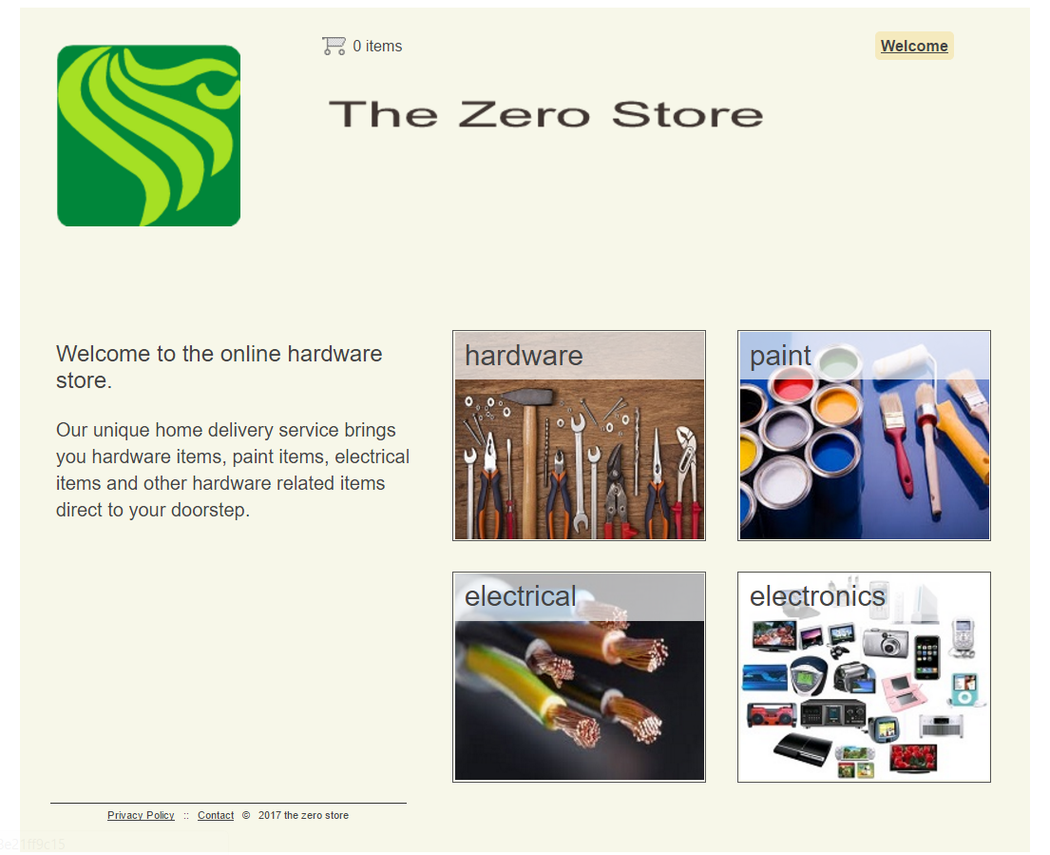

The information about products is stored in “product” table. The user can know the
Name of the product, price of the product, Description at the store. A link to add the product to the shopping cart. The user does not have to login to add a product to the cart or to purchase.

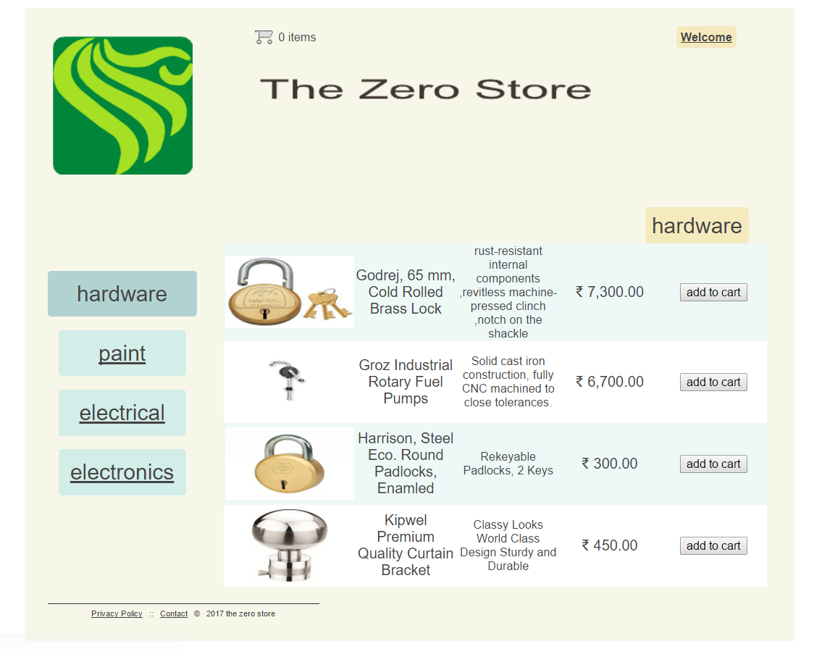

All the products related to the category id is listed on the next page. When user chooses a product and adds it to cart view cart and proceed to checkout widget bar is enabled.
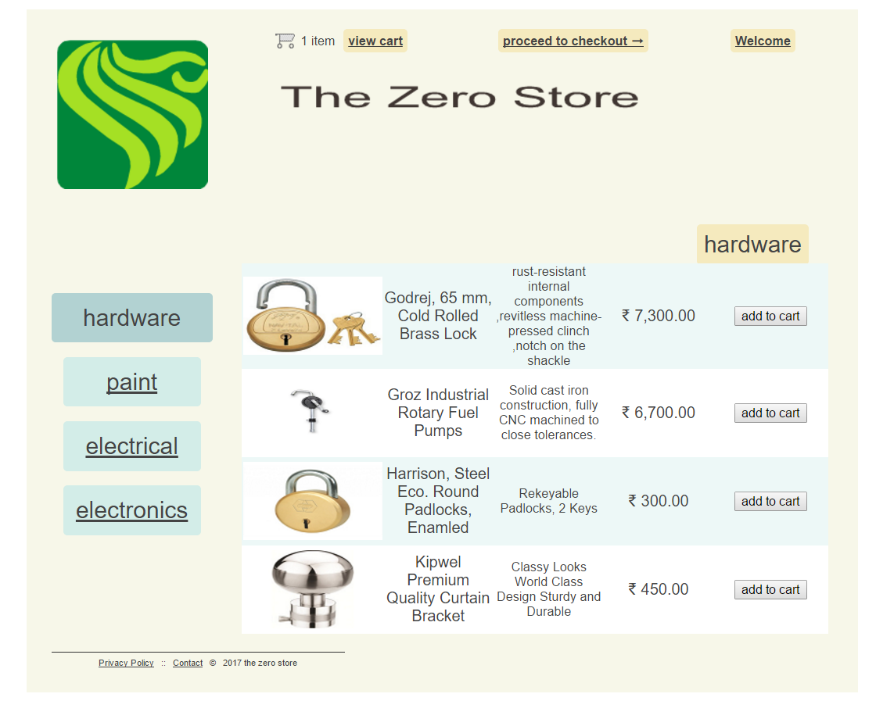

When we click on view cart the cart page is displayed. And if we input 1 – 99 value in quantity part the cart is updated. And if 0 is inputted the cart is clear and continue shopping is clicked user is returned to page where it left while adding the product in cart.
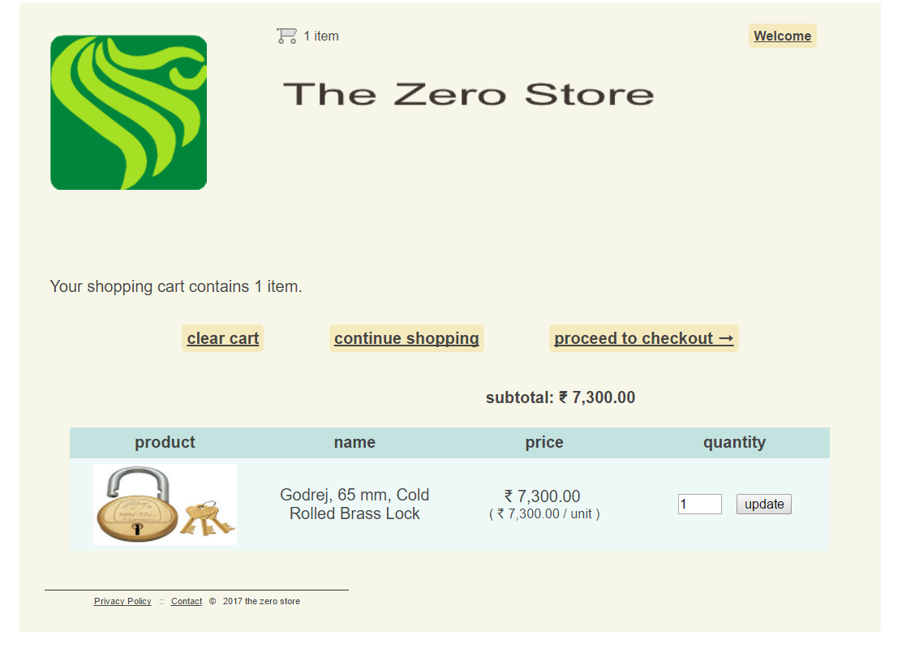

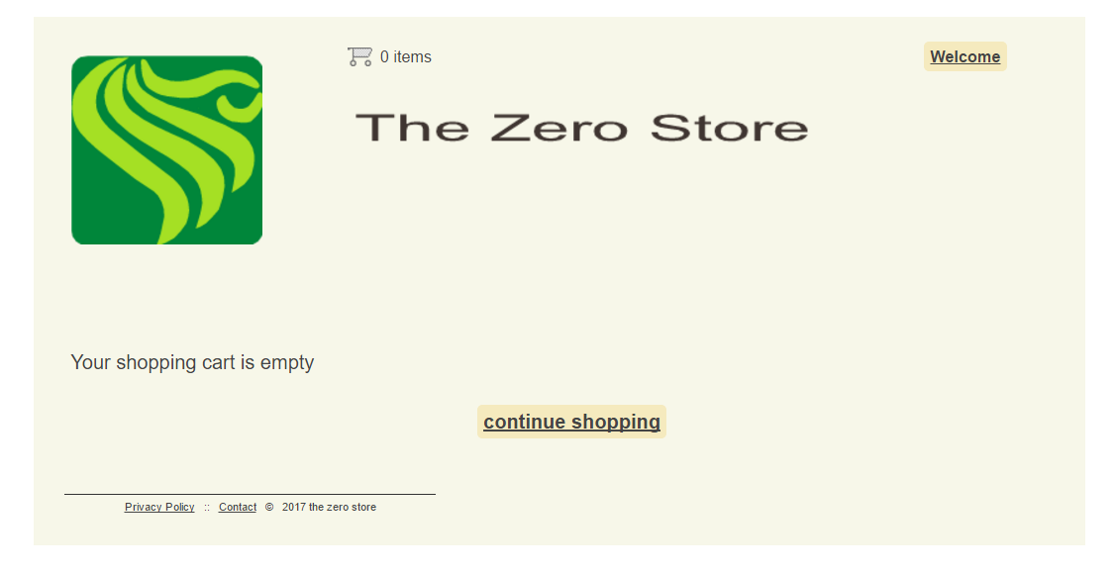
On checkout page name, email, phone etc. are filled out. And if the user provides a wrong input the JavaScript enabled validation validates.

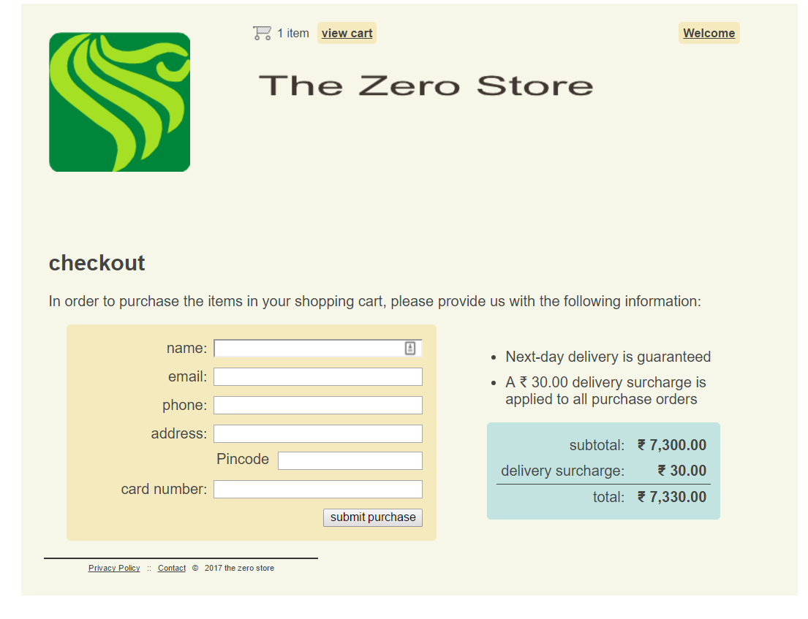

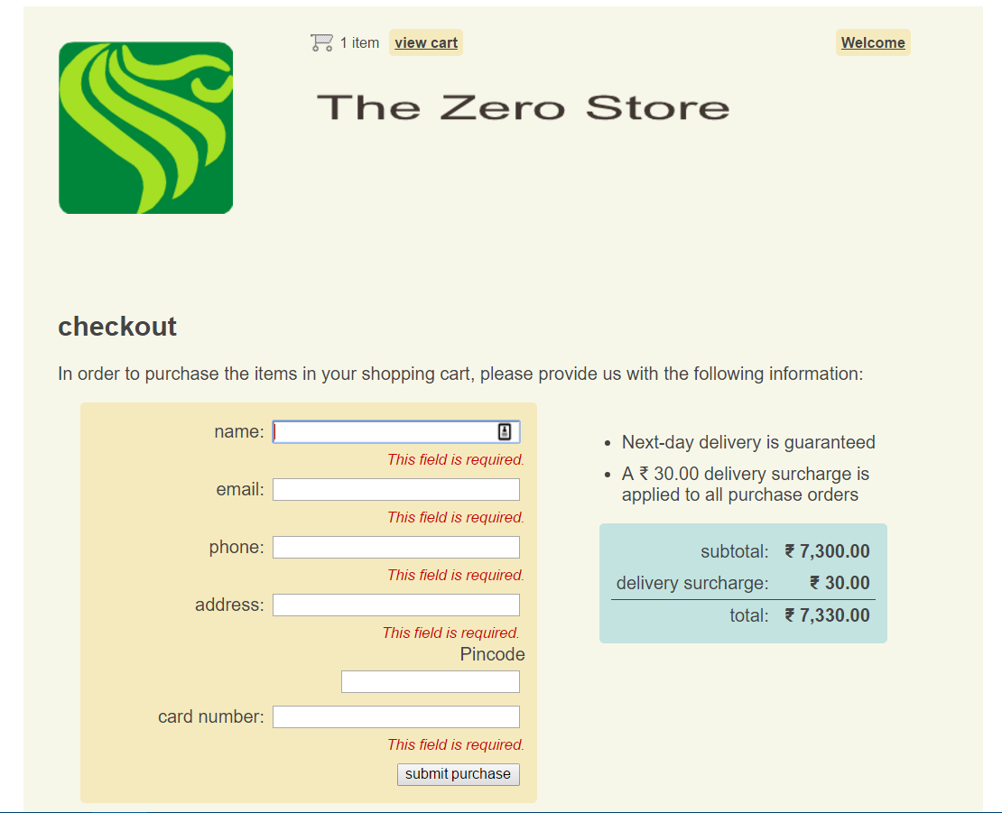

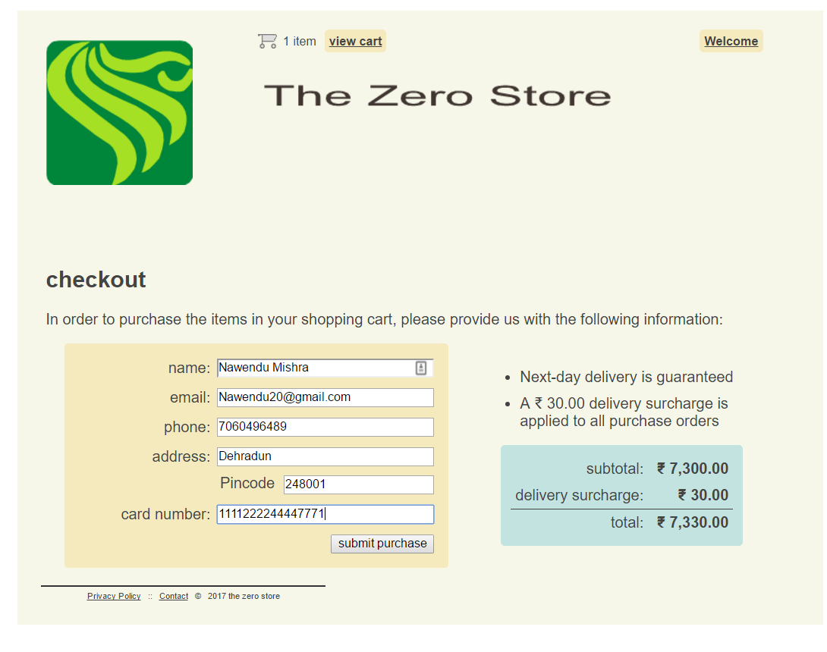

Confirmation and Order summary page

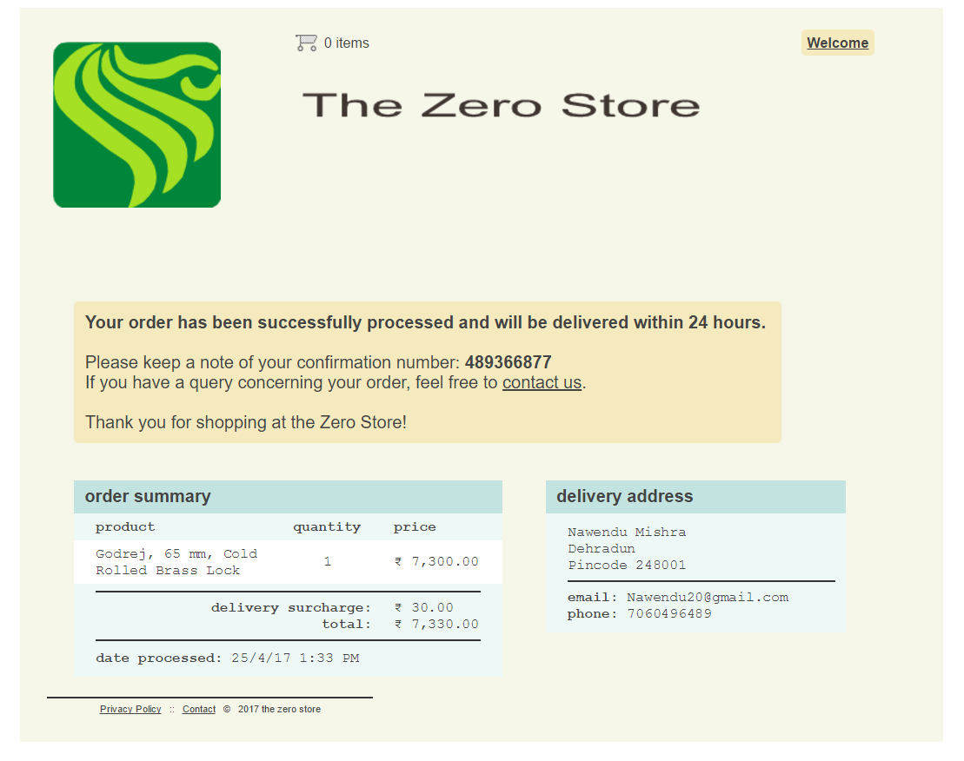

Login Page

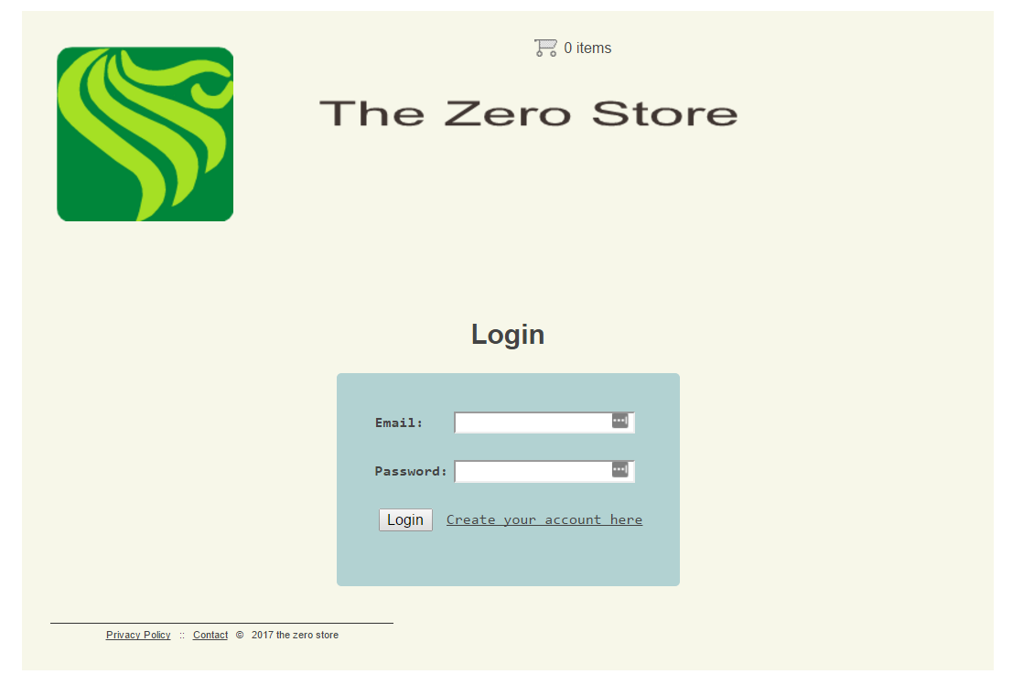

Admin Page

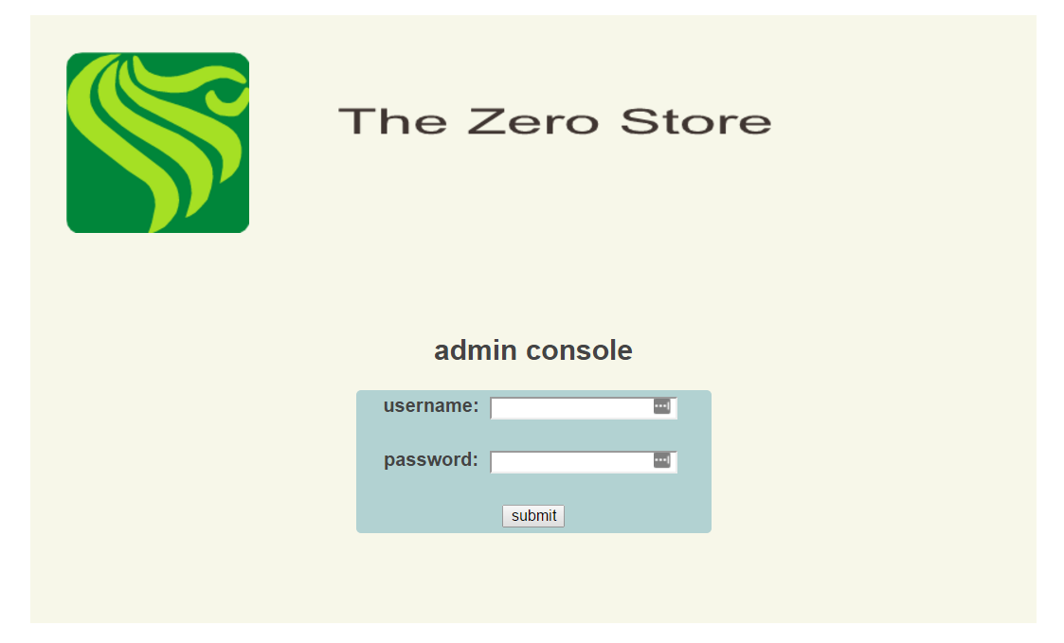

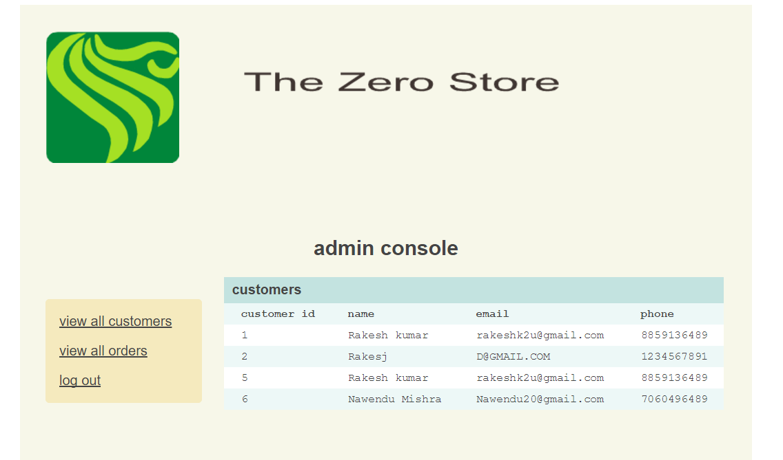

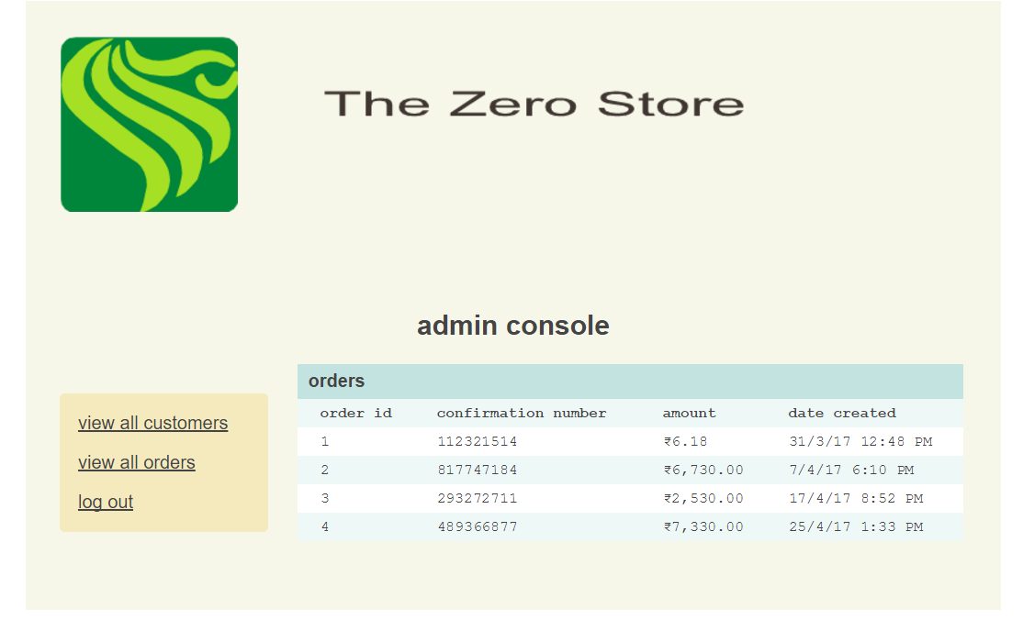

CHAPTER 6

TRANSACTIONS IN THE APPLICATION

6.1 ACID TEST

A transaction is a group of database commands that are treated as a single unit. Transaction must pass what is known as the ACID test:

Atomic: All operations in the transaction are executed properly or none. In other words, they make up a single unit of work. For example, if a customer moves and a transaction is used to reflect that change in the database, all parts of the address must be changed as an atomic action, and so on.

Consistent: The execution of a single transaction preserves the consistency of the database. All the relationships between data in a database are maintained correctly. For example, if customer information uses a tax rate from a state tax table, the state entered for the customer must exist in the state tax table.

Isolation: Each transaction is unaware of the other transactions occurring concurrently. Changes made by other clients cannot affect the current changes. For example, if two data entry operators try to make a change to the same customer at the same time, one of two things occurs: either one operator's changes are accepted and the other is notified that the changes were not made, or both operators are notified that their changes were not made. In either case, the customer data is not left in an indeterminate state.

Durability: Changes the transaction has performed persist in the database. Once a change is made, it is permanent. If a system error or power failure occurs before a set of commands is complete, those commands are undone and the data is restored to its original state once the system begins running again. Transaction processing is particularly important for Web applications that use data access, since Web applications are distributed among many different clients. In a Web application, databases are a shared resource, and having many different clients distributed over a wide area can present these key problems:

- Contention for resources. Several clients might try to change the same record at the same time. This problem gets worse the more clients you have.
- Unexpected failures. The Internet is not the most reliable network, even if your Web application and Web server are 100 percent reliable. Clients can be unexpectedly disconnected by their service providers, by their modems, or by power failures.
- Web application life cycle. Web applications do not follow the same life cycle as Windows applications—Web forms live for only an instant, and a client can leave your application at any point by simply typing a new address in their browser.

Transaction processing follows these steps:

- Begin a transaction.
- Process database commands.
- Check for errors.
- If errors occurred, restore the database to its state at the beginning of the transaction. If no errors occurred, commit the transaction to the database.

CHAPTER 7

CONCLUSION

7.1 LIMITATION AND FUTURE WORK

There are some limitations for the current system to which solutions can be provided as a future development:

- The system is not configured for multi- users at this time. The concept of transaction can be used to achieve this.
- The Website is not accessible to everyone. It can be deployed on a web server so that everybody who is connected to the Internet can use it.
- Credit Card validation is not done. Third party proprietary software can be used for validation check.

As for other future developments, the following can be done:
- The Administrator of the web site can be given more functionalities, like adding a category, product etc.
- Multiple Shopping carts can be allowed.

7.2 CONCLUSION

The Internet has become a major resource in modern business, thus electronic shopping has gained significance not only from the entrepreneur’s but also from the customer’s point of view. For the entrepreneur, electronic shopping generates new business opportunities and for the customer, it makes comparative shopping possible. As per a survey, most consumers of online stores are impulsive and usually make a decision to stay on a site within the first few seconds. “Website design is like a shop interior. If the shop looks poor or like hundreds of other shops the customer is most likely to skip to the other site”. Hence we have designed the project to provide the user with easy navigation, retrieval of data and necessary feedback as much as possible.

In this project, the user is provided with an e-commerce web site that can be used to buy books online. To implement this as a web application we used JAVA as the Technology. JAVA has several advantages such as enhanced performance scalability, built-in security and simplicity.

A good shopping cart design must be accompanied with user-friendly shopping cart application logic. It should be convenient for the customer to view the contents of their cart and to be able to remove or add items to their cart. The shopping cart application described in this project provides a number of features that are designed to make the customer more comfortable.

This project helps in understanding the creation of an interactive web page and the technologies used to implement it. The design of the project which includes Data Model and Process Model illustrates how the database is built with different tables, how the data is accessed and processed from the tables. The building of the project has given me a precise knowledge about how ASP.NET is used to develop a website, how it connects to the database to access the data and how the data and web pages are modified to provide the user with a shopping cart application.

7.3 REFERENCES

- Morrison, M., Morrison, J., and Keys, A. (2002). Integrating Web Sites and Databases Communications of the ACM, September, Volume 45, Issue 9.

- Fundamentals of software engineering By Rajib Mall, Second Edition.

- http://docs.oracle.com/javase/tutorial/

- https://www.skillshare.com/classes/Web-Design-Essentials-Creating-Marketing-Homepages-That-Drive-Results/1513598221

- https://www.manning.com/books/ejb3-in-action

- Chen, L. (2000). Enticing Online Consumers: A Technology Acceptance
Perspective Research- in-Progress. ACM Proceedings, SIGCPR.

- Diwakar, H., Marathe, M. (2000). The architecture of a one-stop web-window shop. December, ACM SIGecom Exchanges, Volume 2 Issue 1.

- Kubilus, N. J. (2000). Designing an e-commerce site for users. September 2000,
Crossroads, Volume 7 Issue 1.

- Norman, D.A. The Design of Everyday Things. Doubleday, New York, 1994.

- Tilson, R., Dong, J., Martin, S., Kieke, E. (1998). A comparison of two current ecommerce sites. September, Proceedings of the 16th annual international conference on Computer documentation.

- http://www.agilemodeling.com/artifacts/dataFlowDiagram.htm for definition of Data Flow Diagram.

